Who’s going to Win the Euro 2012
England 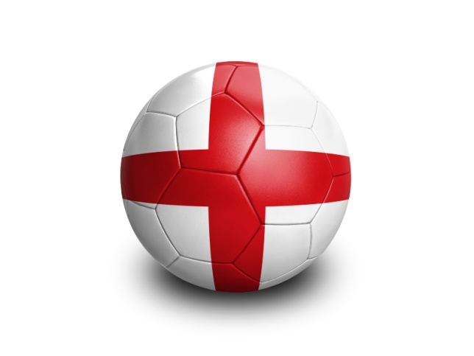
France
Germany
Spain 