Which is Most Read
Power Rangers now on Kix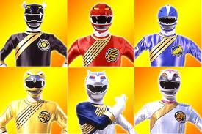
Power Ranger Dino Thunder now on Kix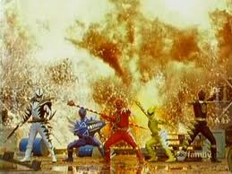
Saturday Smackdown on Kix
Toon Afternoon on Kix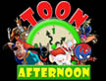
Power Rangers S.P.D coming soon to Kix