The Green Genie
UNIT 3 Phonics
Activity A Write yes or no.
Yes
No
Yes
No
No
Yes

Activity B Write the correct word.
1 A snail has a shell.
2 Do not slip in the mud.
3 A baby can crawl on the floor.
4 I like to drink milk and orange juice.
5 Mammy has a clip dress.
6 Stick the star on the book with glue.
7 My sister has a brown in her hair.
8 Two cars had a crash.

Activity C Read and draw.
A frog on a grey stone. 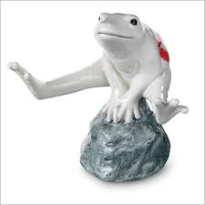
A slice of cake on a plate. 