The Green Genie
UNIT 1 Phonics
Activity A Read the words. Colour the –all words.
hall sell bill wall
tell fill ball full
doll small hill tall
fall bull call stall

Activity B Choose the correct word for each sentence.
1 My new kitten is very (fall, small) small
2 Daddy is a (tall, ball) tall man.
3 Mum will (small, call) call the doctor.
4 The bird sat on the (wall, hall, fall) wall.
5 The children are playing with a (stall, ball, sell) ball.

Activity C Write the correct sentence for each picture.
The girl has a red ball. 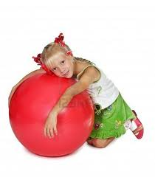
The monster sat in the hall.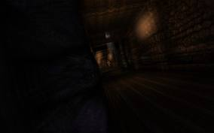
I saw a book stall in town.