Supermanc’s
Supermanc’s is Ireland’s largest and fastest growing indigenous fast food group. The first supermac’s opened its door as far back as 1978 in main Street, Ballinasloe, Co. Galway. Since then, supermac’s has gone from strength to strength with a turnover well in excess of €82m and well over 2500 employees.
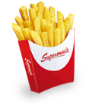
About Us
Supermac’s is Ireland’s largest and fastest-growing indigenous fast food group. The first Supermac’s opened its doors as far back as 1978 in Main Street, Ballinasloe, Co. Galway. Since then, Supermac’s has gone from strength to strength with a turnover well in excess of €82m and well over 2500 employees. With over 100 stores throughout Ireland & Northern Ireland along with aggressive expansion plans, Supermac’s is looking forward to an exciting future!
Supermac’s was founded by Pat McDonagh, the Company’s Managing Director and a school teacher by profession. After five years of teaching in Kilrickle, Co. Galway, Pat spotted an opportunity in Ireland’s quick service restaurant business and decided to pursue it. Since then Supermac’s has become the success story of the Irish restaurant industry.
Much of the success of Supermac’s can be attributed to the company’s intuitive understanding of Irish consumers’ tastes and preferences. Supermac’s is attributed as the pioneer of such Irish delicacies as the “curry chips” and the “snack box”.
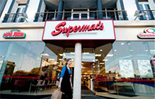
Corporate
“At Supermac’s we believe in providing our customers with the best quality food, service and value delivered by a friendly, motivated team in a clean and welcoming environment unique to Supermac’s”.
Supermac’s is Ireland's largest and fastest-growing indigenous fast food group. The first Supermac’s opened its doors as far back as 1978 in Main Street, Ballinasloe, Co. Galway, Ireland. Since then, Supermac’s has gone from strength to strength with a turnover well in excess of 82m and well over 2500 employees. With over 90 stores throughout Ireland and aggressive expansion plans, Supermac's is looking forward to an exciting future!
Supermac’s was founded by Pat McDonagh, the Company’s Managing Director and a school teacher by profession. After five years of teaching in Kilrickle, Co. Galway, Pat spotted an opportunity in Ireland’s quick service restaurant business and decided to pursue it. Since then Supermac’s has become the success story of the Irish restaurant industry.
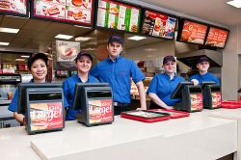
Careers
The first Supermac’s opened its doors back in 1978 in Main Street, Ballinasloe. Currently Supermac’s operates over 100 stores nationwide and employ in excess of 2,200 people.
Supermac’s are expanding at an unprecedented rate, with over 100 restaurants open all over Ireland and aggressive expansion plans both in the Republic and in Northern Ireland. As a result, we have many great opportunities at all levels within the company.
If you are interested in meeting people in a lively and ever changing environment, then Supermac’s is the place to work. We offer full and part-time positions, ranging from 15 - 40 hours weekly, with flexibility to suit all lifestyles and commitments. Extensive training supports each stage of an employee's development while promotional opportunities are always available. Characteristic of success employees is commit to excellence in every aspect of their work.
The company’s success is built on a unique menu, ideally suited to Irish tastes, using real food and food ingredients, and enhanced by quality in every aspect of the operation. The quality philosophy has been recognised by the Gilbey’s Award for food Excellence and the Excellence Ireland Hygiene Mark. Supermac’s Management and Staff, who offer the restaurants their unique, friendly atmosphere, underwrite the quality of service.
If you are interested in joining Supermac’s team, at management or staff level, email your CV to recruitment@supermacs.ie. View our Current Vacancies here.
Alternatively, contact our Human Resources Department at +353 (0)91 774 100 during office hours.
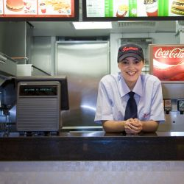
Get in touch
Supermac’s currently operates over 100 restaurants in most major cities and towns throughout the Republic and Northern Ireland. To view contact details for Supermac's outlets view our locations map.
The Company Headquarters and Distribution Centre are in Galway.
At Supermac’s we welcome your comments and questions and want to hear about your experiences at Supermac’s outlets.
For Career Opportunites please view Careers Page or alternatively emailrecruitment@supermacs.ie

Your Contact Details
Your Name: Dennis
Email: paul_onuoha@yahoo.com
Phone: 0871445118
Request: I want i big burger’s and fries and chicken in a snack box because i love it.

