The David Beckham Academy
Soccer Sudoku
To solve this kickin Sudoku puzzle, you must fill every
column, every row and every box with different pictures. It’s
as deadly as Beckham’s right foot! Use your stickers to
complete the grid.

Remember: Each picture can only appear once in each,
column, row and box!
 | 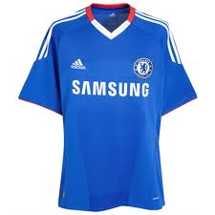 |  | 