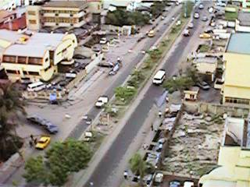
Ajose Adeogun in Victoria Island (in Lagos State).

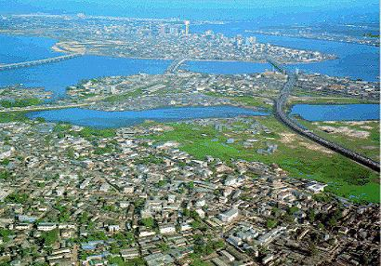
Surulere (Lagos State. You can also see Iganmu, Lagos Island, Ikoyi, & Apapa).

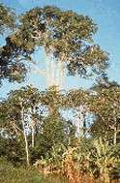
A forest region.

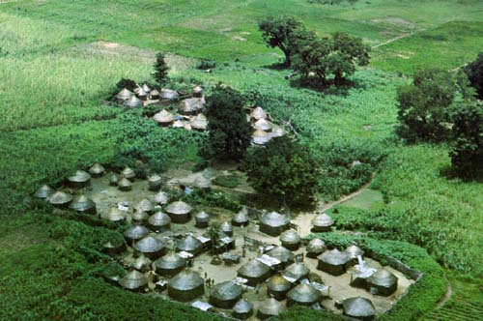
A village in the North.
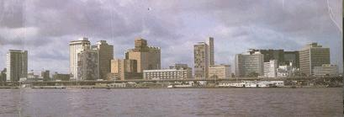
Lagos City (in Lagos State)

