Nelson Mandela
- Nelson Mandela born 18 July 1918 is a South African politician who served as president of South Africa from 1994 to 1999 the first ever to be elected in a fully representative democratic election. Before being elected president, Mandela was a militant ant-apartheid activist and the leader and co-found of Umkhonto we Size, the armed wing of the Africa National Congress (ANC). In 1962 he was arrested and convicted of sabotage and other charges, and sentenced to life imprisonment. Mandela went on to serve 27 years in prison, spending many of these years on Robben Island. Following his release from prison on 11 February 1990, Mandela led his party in the negotiations that led to the establishment of democracy in 1994. As president, he frequently gave priority to reconciliation, while introducing policies aimed at combating poverty and inequality in South Africa. In South Africa, Mandela is often known as Madiba, his Xhosa clan name or as tata (Xhosa: father). Mandela has received more than 250 awards over four decades including the 1993 Nobel Pace Prize.
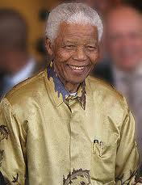
List of Haplogroups of historical and famous figures
- List of haplogroups of historical and famous figures. Haplogroups can be determined from the remains of historical figures, of derived from genealogical DNA tests of people who trace their direct maternal or paternal ancestry to a noted historical figure. Some contemporary notable figures have made their test results public in the course of news programs about this topic.
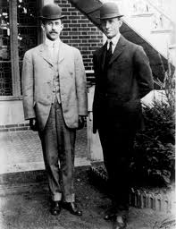
University of KwaZulu-Natal
- The University of KwaZulu-Natal o UKZN is a university with five campuses all located in the province of KwaZulu-Natal in South Africa. It was formed on 1 January 2004 after the merger between the University of Natal and the University of Durban- Westville.
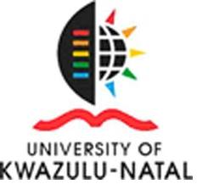
Legends of Africa
- Africa has a wealth of history which is largely unrecorded. Myths, fables and legends abound.
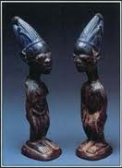
Free Nelson Mandela (sculpture)
- Free Nelson Mandela is a sculpture in Atlanta, Georgia, USA, created by David Hammons in 1987. Alternatively referred to as a monument, the piece was originally created as a statement demanding the liberation of the imprisoned South Africa to Peace and Prosperity. However, it is most frequently called just Free Nelson Mandela, because those words are carved in the face of the granite rock that is the bottom portion of the sculpture. The top portion is a 12 feet high fence of iron bars radiating from the rock and topped with barbed wire. In the fence is a working gate, which had been left with Atlanta city officials by the artist. The gate has remained in an open position ever since, and the rock proclaims that there is now a Free Nelson Mandela. There are also small segments of chain attached to the bottom corners of the rock, adjacent to the base. At some point after the gate was opened, three bars to the right of the gate were painted, respectively, green, black, and yellow, the colours of the South African flag. The entire sculpture weighs 7 tons.

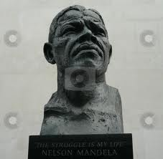
- ambican Tupolev Tu-134 crash
- The Mozambican presidential Tupolev Tu-134A-3 aircraft crashed just inside South African territory on October 19, 1986. The aircraft was carrying Mozambican president Samora Machael and 43 other occupants on a flight from Mbala in Zambia to the Mozambican capital Maputo when it crashed 35 nautical miles (65 km) west of its destination at Mbuzini in the Lebombo Mountains. Nine passengers and one crew member survived the crash, but President Machael and 33 others died, including ministers and officials of the Mozambique government.
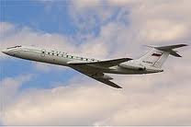
Honorary appointments to the Order of Canada
- The order’s constitution permits the appointment of five honorary members of the Order of Canada per year. The following is a list of all honorary appointments to date those rendered in italics were later made Canadian citizens and thus no longer regarded as honorary inductees.
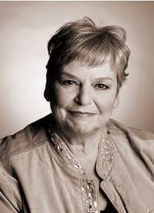
Global Movement for Children
- The Global Movement of Children (GMC) is the world-wide movement of organisations and people – including children- uniting efforts to build a world fit for children. The GMC was created as a result of the outstanding success of the Say Yes for Children campaign which led to the (UN Special Session on Children in 2002 resolving to help mobilize citizens of every nation families, communities, civil society, organizations of every kind and children within an active, influential and united movement. The main objectives of the GMC are to.
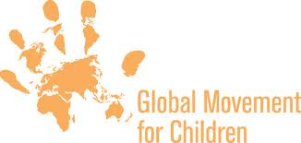
The Amazing Race 2
- The Amazing Race 2 is the second instalment of the reality television show The Amazing Race. The Amazing Race 2 featured 11 teams of two with a pre-existing relationship in s race around the world, It premiered on March 11 2002 and ended on May 15 2002. Childhood friends Chris Luca and Alex Boylan won this edition of the race. The complete season was released on DVD, January 24, 2011, exclusively on Amazon.com via its Create Space program.
