Turkey  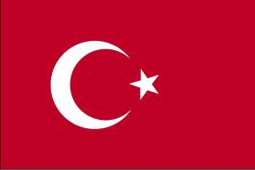  Captain  Brady  Christian  Christopher  Felize S  Fhrica  Oscar  Maxim | Belgium  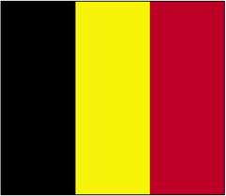  Captain  Annie  Eddie  Jack  Felize ON  Minnie  Nora  Ranne
Australia  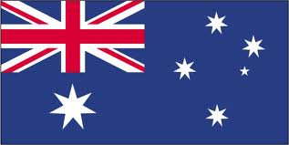  Captain  Michael  Tara ON  Jules  Kevin  Naise  Dominic | Kazakhstan  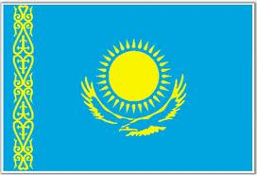  Captain  Daniel  Isabella  Judy  Oran  Omar  Rínnie

