France  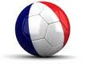  Captain  Francily  Stanley  Josh  David  Kean  Kanza  Eston | Ukraine  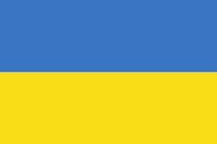  Captain  Grady  Stephen  Jessie  Robert  Christopher  Sean  Beleshow
Spain  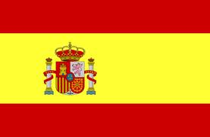  Captain  Adam  Abraham  John  Joseph  Dilin  Dessy  Alley | Ireland  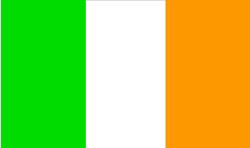  Captain  Patrick  Eliot  Phillip  Dennis  Mikey  Princewell  Samuel

