My Spelling Workbook
List Word
Soap
Loaves
Count
Hour
South
Sound
Shout
Proud
Mouse
Thousand
Mountain
Basket
Basketball
Dentist
Bottom
Blind
Being
Animal
Subtract
Divide
Multiply
Modem

9. Find a small word in these list words.
(a) South=out
(b) Basket=as
(c) Soap=so
(d) Shout=out

10. Write the correct noun from the list words. Draw the picture these adjectives describe.
(a) Tall, mighty=
(b) Clean, perfumed=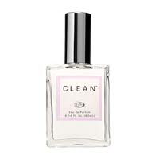

11. Put these words into alphabetical order.
Animal, basket, being, blind, bottom, dentist, divide, hour, mountain, mouse, multiply, pround.

