My Spelling workbook
List words
lace
shade
safe
page
shake
snake
plane
base
case
chase
hate
mate
plate
brave
grapes
picnic
plum
comic
gift
grand
pants
pollute

Revision Word
cable
place
deck
song
cent
close
litre
aunt
stuck
text
cage
door
lift
seal
fear
made
ice
egg

10. Complete, using list words.
(a) She won first prize in the competition.
(b) The most exciting act at the circus was the trapeze artists.
(c) He had to fill his car with petrol.
(d) The mice had gnawed at the box so badly, it was ready to
fall apart.

11. Write the correct noun from the list words. Draw the
picture these adjectives.
(a) mice nibbling scampering, nibbling

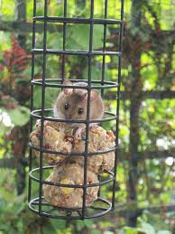

(b) circus exciting enteraning

