The David Beckham Academy
Kick off by creating your very own player profile. Then
design your own shirt, using your favourite colours.
My Profile
Name: Dennis
Age: 11
Team i player for: Man U
position: Goalkeeper
Favourite player: Rooney
Favourite Club Team: Man U
Favourite international Team: Ireland

Shirt: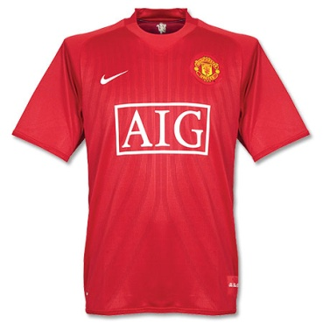

My Autograph: Dennis Onuoha

