**My Life In Box**

**My Name: Dennis** 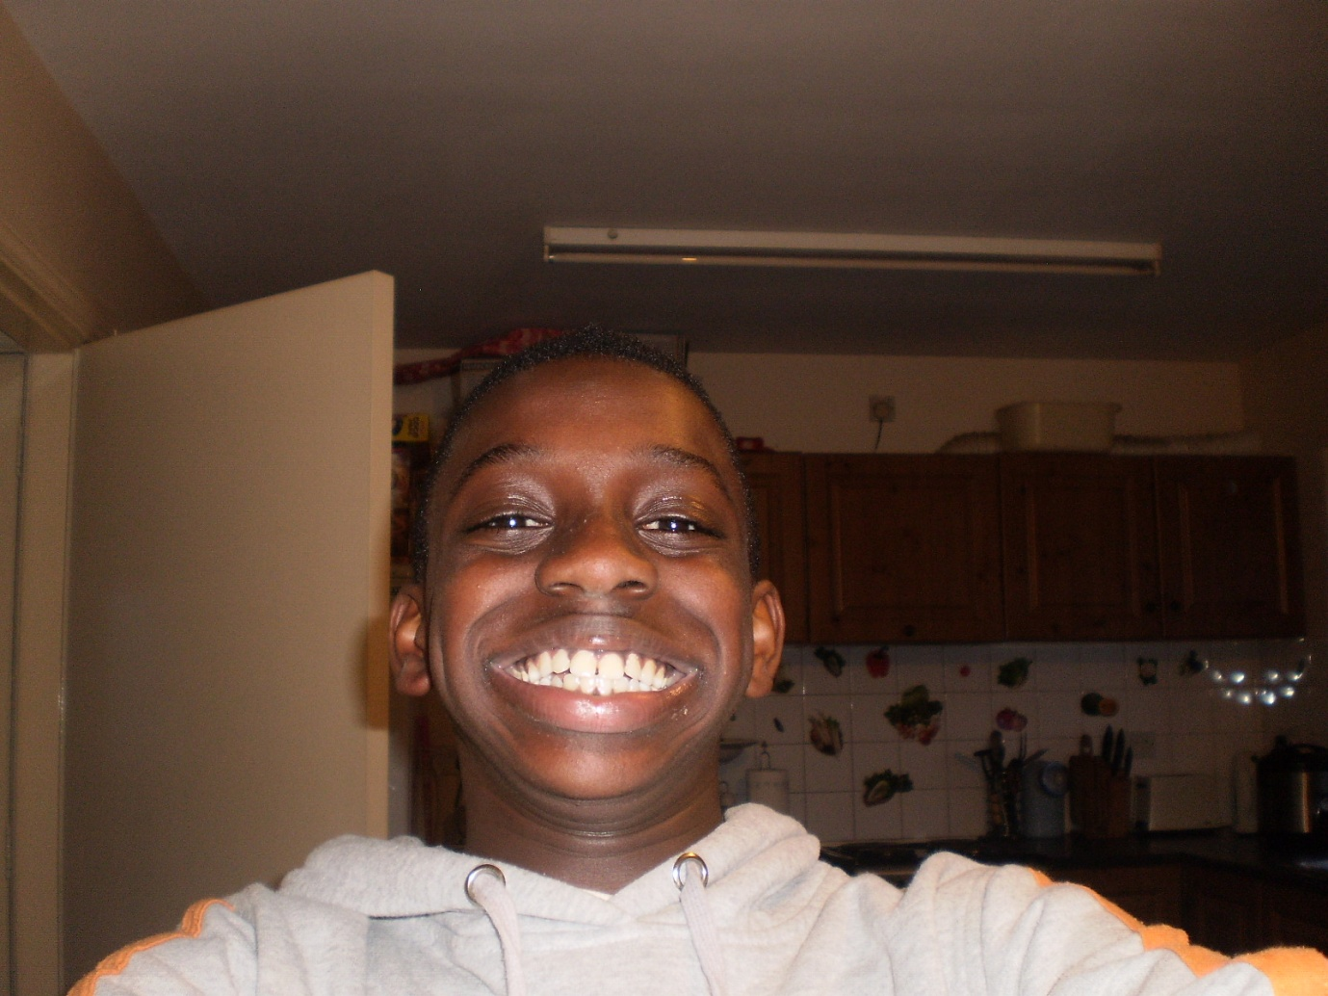

**My Brother’s Name: Christopher** 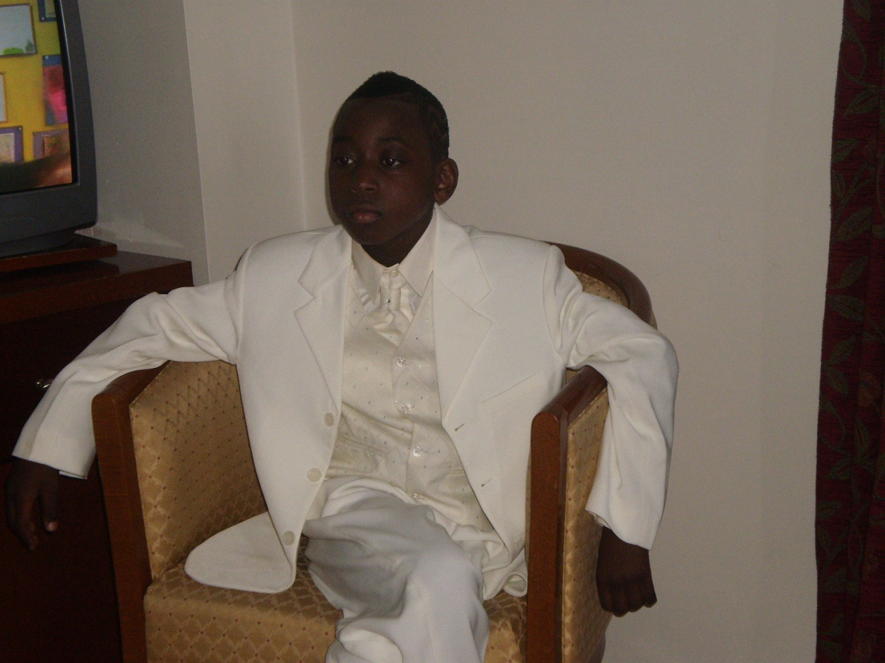

**My Favourite Song: Specious minds by Elvis Presley, The Flying Pickets only you** 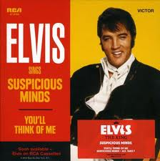 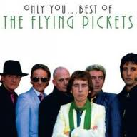

**My Favourite Food: Spaghetti, Lasagne, Pizza** 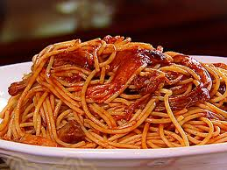 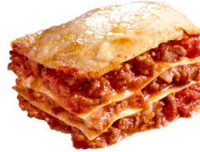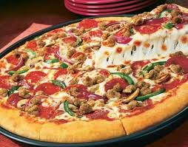

**My Favourite Bar: Toffee Crisp, Mars Bar, Carmac Bar** 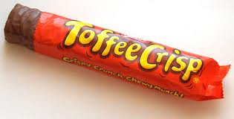 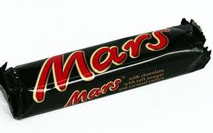 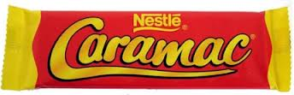

**My Favourite Country: Nigeria, Kinshasa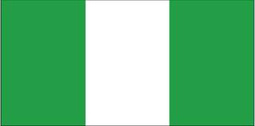 **

**My Favourite Jean’s: Denim** 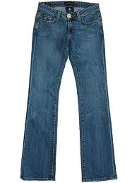 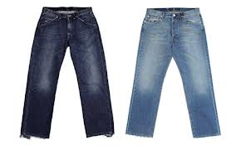

**My Favourite French Food: Croissants** 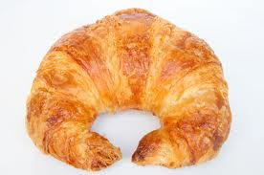

**My Favourite Medals: This is my favourite medals from the Olympic Handball** 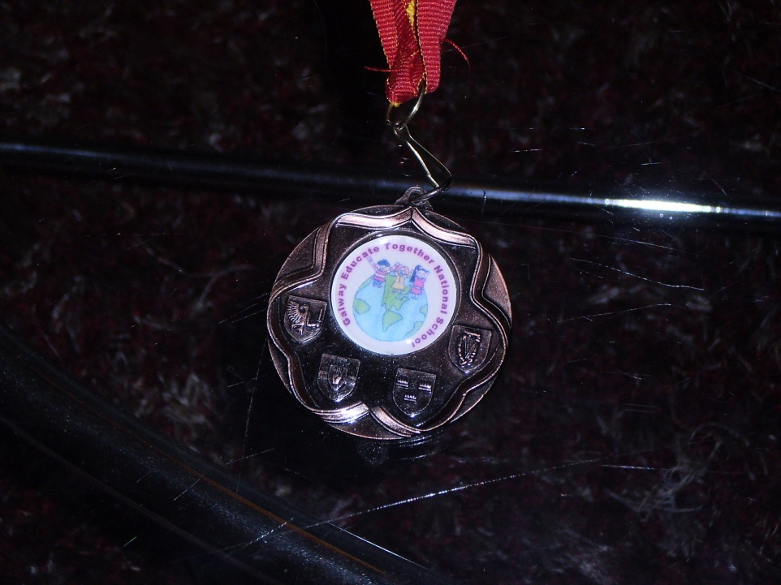

**My Favourite, Fast food: Supermancs KFC, Mc Donalds**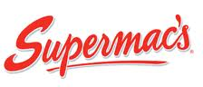  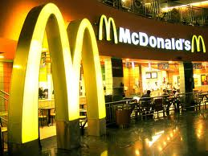

**My Favourite Shop: Two Pound Shop** 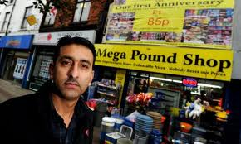

**My Favourite Colour: Red Yellow  **

**My Favourite T.V Show: Fantastic MR. Fox, SpongeBob Squarepants 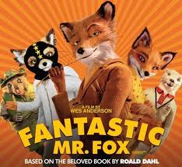 **

**My Favourite CD: Shrek** 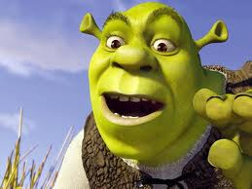

**My Favourite Dessert: Strawberry Sundae** 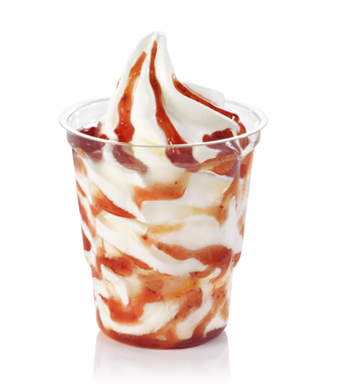

**My Hobby’s: Football, and going mad  **

**My Favourite season: Summer, Winter  **

**My Favourite Cartoon Character: **

**My Favourite: Bed** 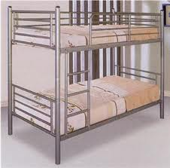

**My Favourite: Car Roadrunner** 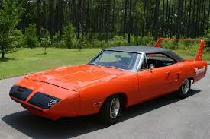

**My Favourite Movie: Dairy of a Wimpy kind** 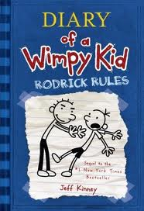

**My Favourite Ice Cream: Flavour Strawberry** 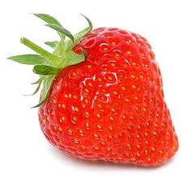

**My Favourite: Subject Maths, English** 