The David Beckham Academy
Football Food
Footy is a great game for keeping you fit, but to perform at your best, you need to eat the right foods too. This food wheel shows how to choose a balanced diet.
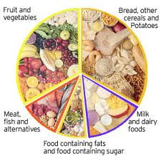
- Fruit and vegetables.
- Bread other cereals and potatoes.
- Milk and dairy foods.
- Food containing fats or sugar.
- Meat, fish and alternatives.
Use the wheel above to help you answer these questions.
Write the letters in the boxes.
- B
- D
- C
- E
- A

